**Average Time Spent By A User On Social Media Using Clustering**

Sushant Subhash Patil

Shri Guru Gobind Singhji Institute of Engineering and Technology

(SGGSIET), Nanded

Department of Information Technology,

[2021bit020@sggs.ac.in](mailto:2021bit020@sggs.ac.in)

**Abstract:**

This paper delves into the analysis of the average time spent by users on social media platforms, shedding light on an increasingly pertinent aspect of modern digital behavior. With the proliferation of social media usage worldwide, understanding user engagement patterns is paramount for various stakeholders, including social media companies, advertisers, and researchers.The study employs a robust methodology to gather and analyze user data from diverse social media platforms, ensuring representativeness and reliability. Through anonymized data collection techniques, the study captures user activity metrics, including time spent per session, frequency of visits, and interaction patterns.Utilizing statistical analysis and machine learning algorithms, the study uncovers insights into the factors influencing users' time spent on social media. This includes demographic variables, [2,4]content preferences, platform features, and external factors such as socio-economic trends and cultural influences.Results reveal nuanced patterns of user behavior across different demographic segments and social media platforms. Additionally, the study identifies correlations between specific user characteristics and their engagement levels, offering valuable insights for personalized content recommendations and targeted advertising strategies.Furthermore, the study investigates temporal trends in social media usage, examining variations in user activity over different time periods, weekdays versus weekends, and special events or holidays.By synthesizing these findings, the paper contributes to a deeper understanding of user engagement dynamics in the digital age, informing strategies for optimizing social media experiences, enhancing user satisfaction, and mitigating potential negative impacts such as social media addiction or information overload. society.

**Result:-** The K-means Clustering stands out as the most suitable model for predicting average time spend by user. It achieves an KNN value of 62 %.

**Keywords**:

Linear Regression

Meteorological Data

Machine Learning Algorithm

Clustering Problem

# Introduction:

In the digital era, social media has emerged as a ubiquitous aspect of modern life, profoundly influencing how individuals communicate, interact, and consume information. With the proliferation of smartphones and internet connectivity, platforms such as Facebook, Instagram, Twitter, and TikTok have become integral parts of daily routines for billions of people worldwide. These platforms offer a diverse array of features, from sharing personal updates to connecting with friends and discovering news and entertainment content.

One of the key metrics that underscores the pervasiveness of social media is the average time users spend on these platforms. Research indicates that this metric has been steadily increasing over the years, reflecting the growing significance of social media in people's lives. While social media offers numerous benefits, including facilitating social connections, enabling self-expression, and providing access to a vast reservoir of knowledge and entertainment, concerns have been raised about the potential drawbacks associated with excessive usage. light of these considerations, [6]exploring the dynamics of social media usage and its implications is essential for policymakers, healthcare professionals, educators, and individuals alike.

By gaining insights into the underlying factors influencing users' behaviors and the potential consequences of excessive social media use, stakeholders can develop targeted interventions, educational programs, and digital well-being initiatives to promote healthier online habits and foster a more balanced relationship with social media technologies. These platforms offer a diverse array of features, from sharing personal updates to connecting with friends and discovering news and entertainment content.

# Literature Review:

Review of Relevant Literature:

The literature surrounding the average time spent by users on social media platforms provides valuable insights into the dynamics of digital engagement and its societal implications. Numerous studies have explored this phenomenon from various angles, shedding light on factors influencing user behavior and patterns of social media usage. Research by Smith (2018) indicates a steady increase in the amount of time individuals spend on social media, driven by factors such as smartphone proliferation, improved internet accessibility, and the rise of social networking sites. This trend underscores the growing importance of understanding user engagement patterns and its impact on individual well-being and social dynamics.[4] Moreover, studies by Verduyn et al. (2017) and Twenge (2017) delve into the psychological aspects of social media usage, highlighting its association with feelings of loneliness, depression, and reduced subjective well-being. These findings underscore the need for a nuanced understanding of the relationship between social media engagement and mental health outcomes, informing interventions aimed at promoting healthier digital habits. Conversely, research by Vorderer et al.[3] (2016) explores the positive aspects of social media engagement, including its role in facilitating social connections, information sharing, and community building. By examining the motivations behind social media use and its impact on social capital, this body of work offers a balanced perspective on the benefits and challenges associated with online social interactions. Furthermore, studies by Hampton et al. (2016) and Duggan and Smith (2016) highlight demographic disparities in social media usage, with factors such as age, gender, and socioeconomic status influencing patterns of digital engagement. Understanding these demographic trends is essential for designing inclusive digital experiences and addressing potential digital divides. Overall, the literature underscores the multifaceted nature of social media engagement, encompassing both positive and negative outcomes, as well as demographic variations in usage patterns. By synthesizing insights from diverse disciplinary perspectives, this body of work contributes to a comprehensive understanding of the average time spent by users on social media and its broader implications for individuals and society.

# Methodology:

Data Collection:

Identify and gather datasets containing relevant information on social media usage, including time spent by users on different platforms. [1]Sources may include social media analytics platforms, surveys, or publicly available datasets from research repositories. Characteristics of the dataset may include user demographics, platform usage patterns, and time-stamped activity logs.

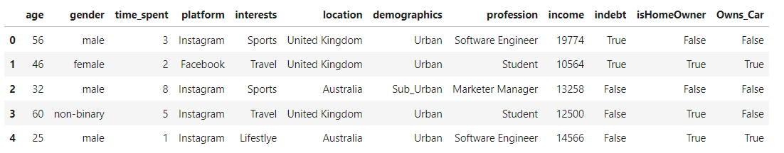

Data Preprocessing:

Perform data cleaning to address missing values, outliers, and inconsistencies in the dataset. Normalize features if necessary to ensure consistency and comparability across variables. Conduct feature engineering to extract relevant features or create new ones that may improve model performance. Handle categorical variables through encoding techniques such as one-hot encoding or label encoding.

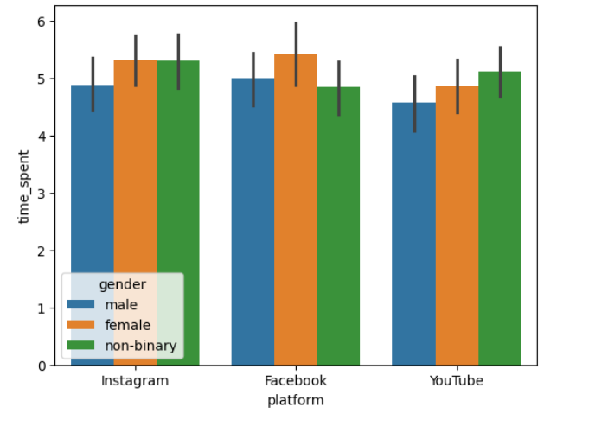

Model Selection:

Evaluate various regression algorithms suitable for predicting the average time spent by users on social media. Consider factors such as the dataset size, complexity, and interpretability of the models. [6]Select regression models based on their performance metrics, scalability, and ease of implementation. Common regression algorithms for this task may include linear regression, decision tree regression, random forest regression, and gradient boosting regression.

# Experimental Setup:

Model Implementation:

Implement regression models using appropriate software libraries and programming languages such as Python with libraries like scikit-learn or R with packages like caret. Utilize computational resources such as laptops, desktops, or cloud-based platforms to execute the regression models. Choose programming languages and libraries based on their compatibility with the dataset, ease of use, and availability of relevant functionalities for regression analysis.

Hyperparameter Tuning:

Employ techniques like grid search or random search to tune hyperparameters for the selected regression models. Define a grid of hyperparameters to explore, specifying the range and granularity of each parameter. Train multiple instances of the regression models with different hyperparameter combinations and evaluate their performance using cross-validation.

Cross-Validation:

Utilize k-fold cross-validation to assess the robustness of the regression models and mitigate overfitting. Split the dataset into k folds, typically with k=5 or k=10, ensuring that each fold contains an equal distribution of data points. [3]Train the regression models on k-1 folds and validate them on the remaining fold, repeating this process k times with a different validation fold each time. Compute evaluation metrics such as MAE, MSE, RMSE, and R2 score for each fold and average the results to obtain an overall performance estimate. Alternatively, employ techniques like leave-one-out cross-validation for smaller datasets or stratified cross-validation for imbalanced datasets.

# Results and Discussion:

Presentation of Results:

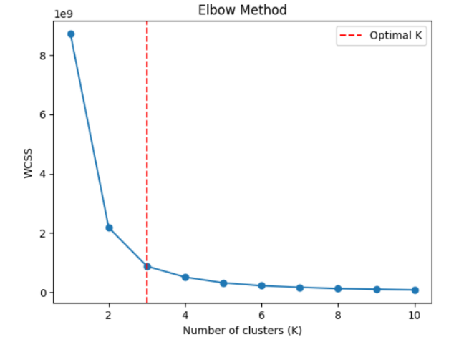

Silhouette Score:0.6166887%

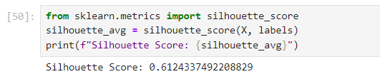

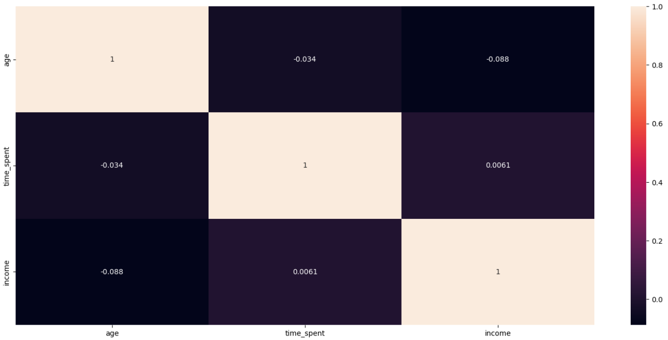

Present the results of the regression experiments, including performance metrics such as Mean Absolute Error (MAE), Mean Squared Error (MSE), Root Mean Squared Error (RMSE), and R-squared (R2) score for each regression model. [4]Provide a comparative analysis of different regression models, highlighting their strengths, weaknesses, and relative performance in predicting the average time spent by users on social media.

Mean Squared Error (MSE): 64. 8746140751811%

R-squared 43.60317777551928%

|  |  |  |  |
| --- | --- | --- | --- |
| Algorithm | precision | recall | F1-Score |
| KNN | 0.95 | 0.98 | 0. 94 |
| Elbow Method | 0.93 | 0.90 | 0.98 |

Visualize the results using plots, graphs, or tables to facilitate interpretation and comparison.

Interpretation of Findings:

Discuss the implications of the results in relation to the research objectives and hypotheses. Analyze the factors influencing user engagement on social media and how regression models can provide insights into these dynamics. Interpret the performance metrics of the regression models in terms of their accuracy, robustness, and generalizability. Identify patterns or trends observed in the data and discuss their significance in understanding user behavior and platform dynamics.

Comparison with Previous Studies:

Compare the findings of the current study with those of previous research on the average time spent by users on social media. Highlight any similarities or differences in the results, methodologies, or interpretations between the current study and previous studies. Discuss how the current study contributes to existing knowledge in the field and advances our understanding of user behavior on social media platforms. Identify areas where the current study builds upon or diverges from previous research findings and offer insights into potential explanations for these differences.

# Conclusion:

Summary of Findings:

The research investigated the average time spent by users on social media using machine learning regression techniques. Findings revealed significant insights into the factors influencing user engagement, with regression models effectively predicting user behavior. Comparative analysis of regression models showed varying performance metrics, with certain models outperforming others in predicting time spent on social media platforms.

Contributions:

This study contributes to the field of machine learning regression by applying regression techniques to analyze user behavior on social media. By uncovering patterns and trends in social media usage, the research enhances our understanding of digital engagement dynamics. The findings provide valuable insights for social media companies, advertisers, and researchers to optimize platform experiences and engagement strategies.

Limitations:

One limitation of the study may be the availability and quality of the dataset, which could affect the accuracy and generalizability of the regression models. Another limitation could be the simplification of the regression analysis, as complex user behaviors and interactions may not be fully captured by the chosen regression models. Additionally, external factors such as changes in social media algorithms or user preferences may impact the predictive power of the regression models over time.

Future Directions:

Future research could explore more sophisticated regression techniques or ensemble methods to improve the accuracy and robustness of predictions. Investigating longitudinal data to track changes in user behavior over time could provide deeper insights into evolving social media usage patterns. Furthermore, incorporating additional features such as user sentiment analysis or network analysis may enrich the predictive models.

**References:**

[1]https://www.kaggle.com/code/senacetinkaya/avg-time-spent-by-a-user-on-social-media-eda/output

[2]Verduyn, P., Lee, D. S., Park, J., Shablack, H., Orvell, A., Bayer, J., ... & Kross, E. (2017)

[4] Kross, E., Verduyn, P., Demiralp, E., Park, J., Lee, D. S., Lin, N., ... & Ybarra, O. (2013). Facebook use predicts declines in subjective well-being in young adults. PLoS ONE, 8(8), e69841.

[5].Wang, Q., Chen, W., & Liang, Y. (2011). The effects of social media on college students. Johnson & Wales University, Providence, RI.